Cole Dorman Game Studio Project 2024/12/06

In this report I will be covering the project management aspect and also my best code contributions to the project. As well as my peer feedback and code reviewing I did. The next few pages will include some images that show the development stages throughout the project via planning. After those I will go in depth into my analysis of my performance.

First iteration with all tasks added:
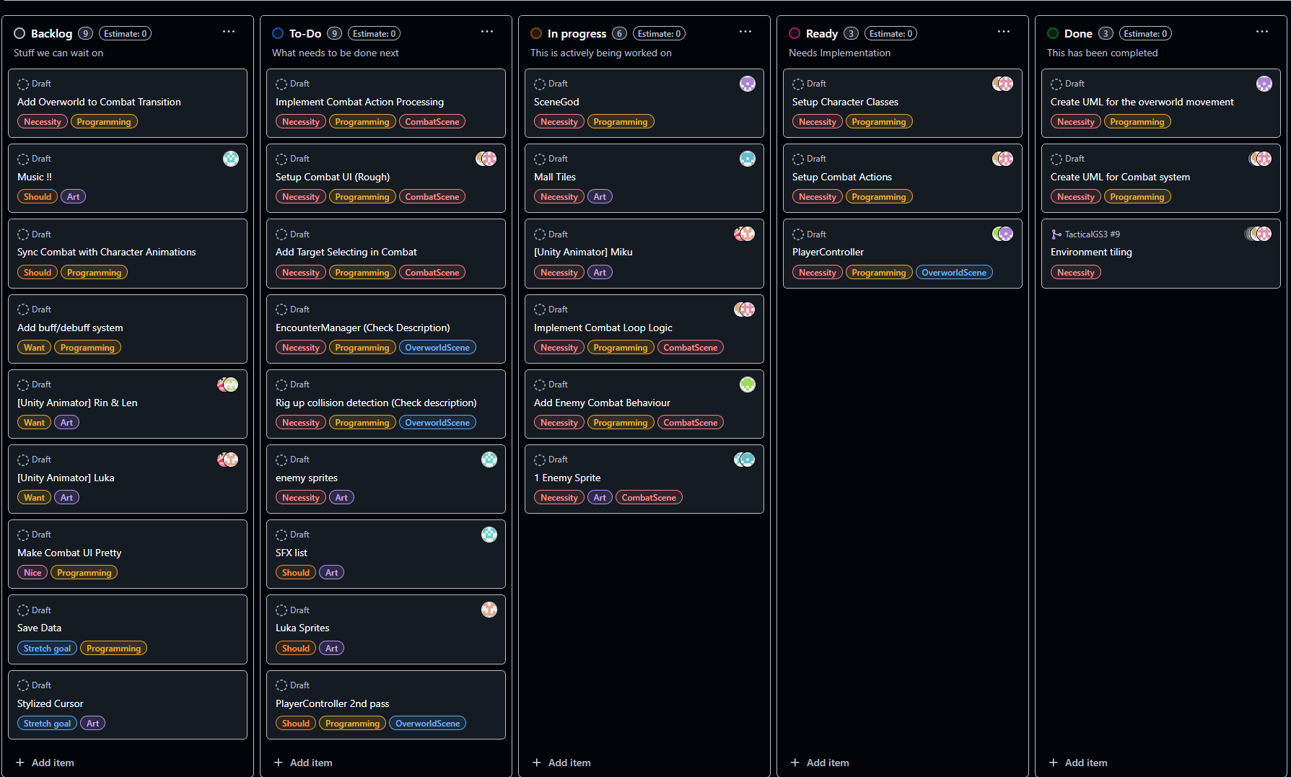

Before deadlines:
Deadlines include me doing my best to estimate the time that would be needed to complete each task, and then assigning the person who will be working on it, that due date. After assigning them I had given everyone a heads up and asked people to please let me know if any deadlines I set had were unrealistic as soon as they notice they won’t be able to make it.
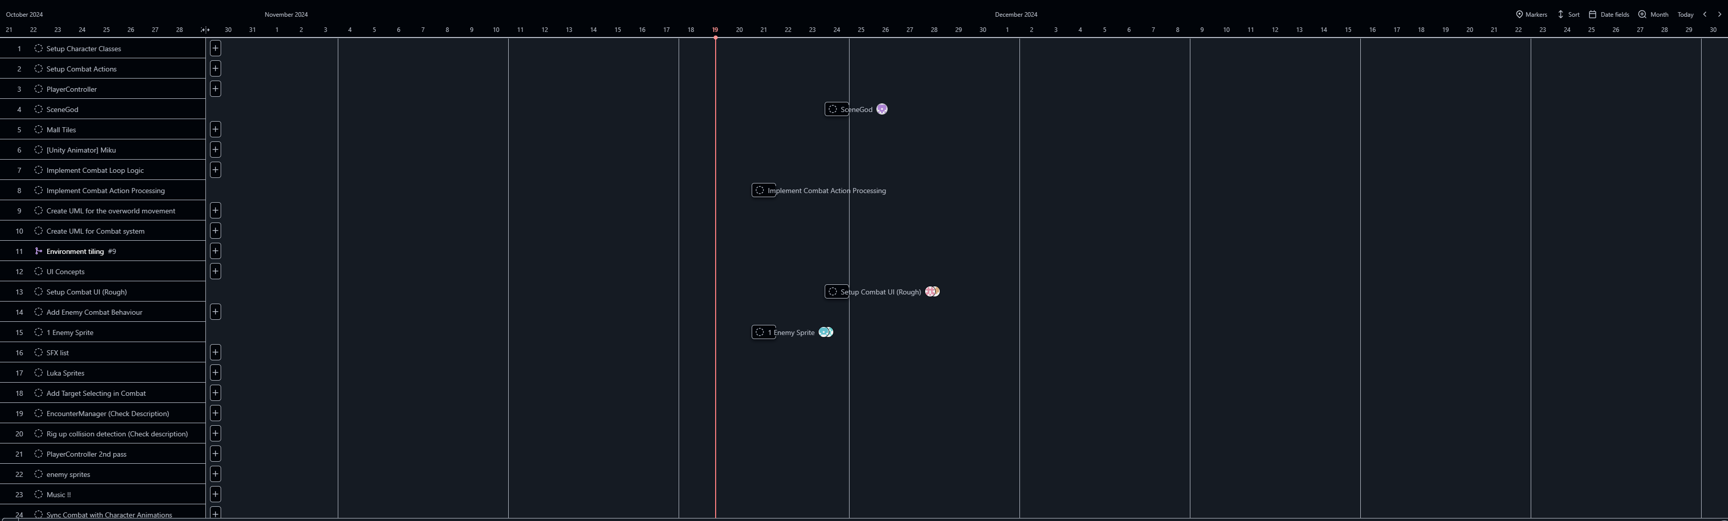

After Deadlines added:
This below shows a table view of all the red tags (Necessity) for our minimum viable product, and their due dates (shown right).
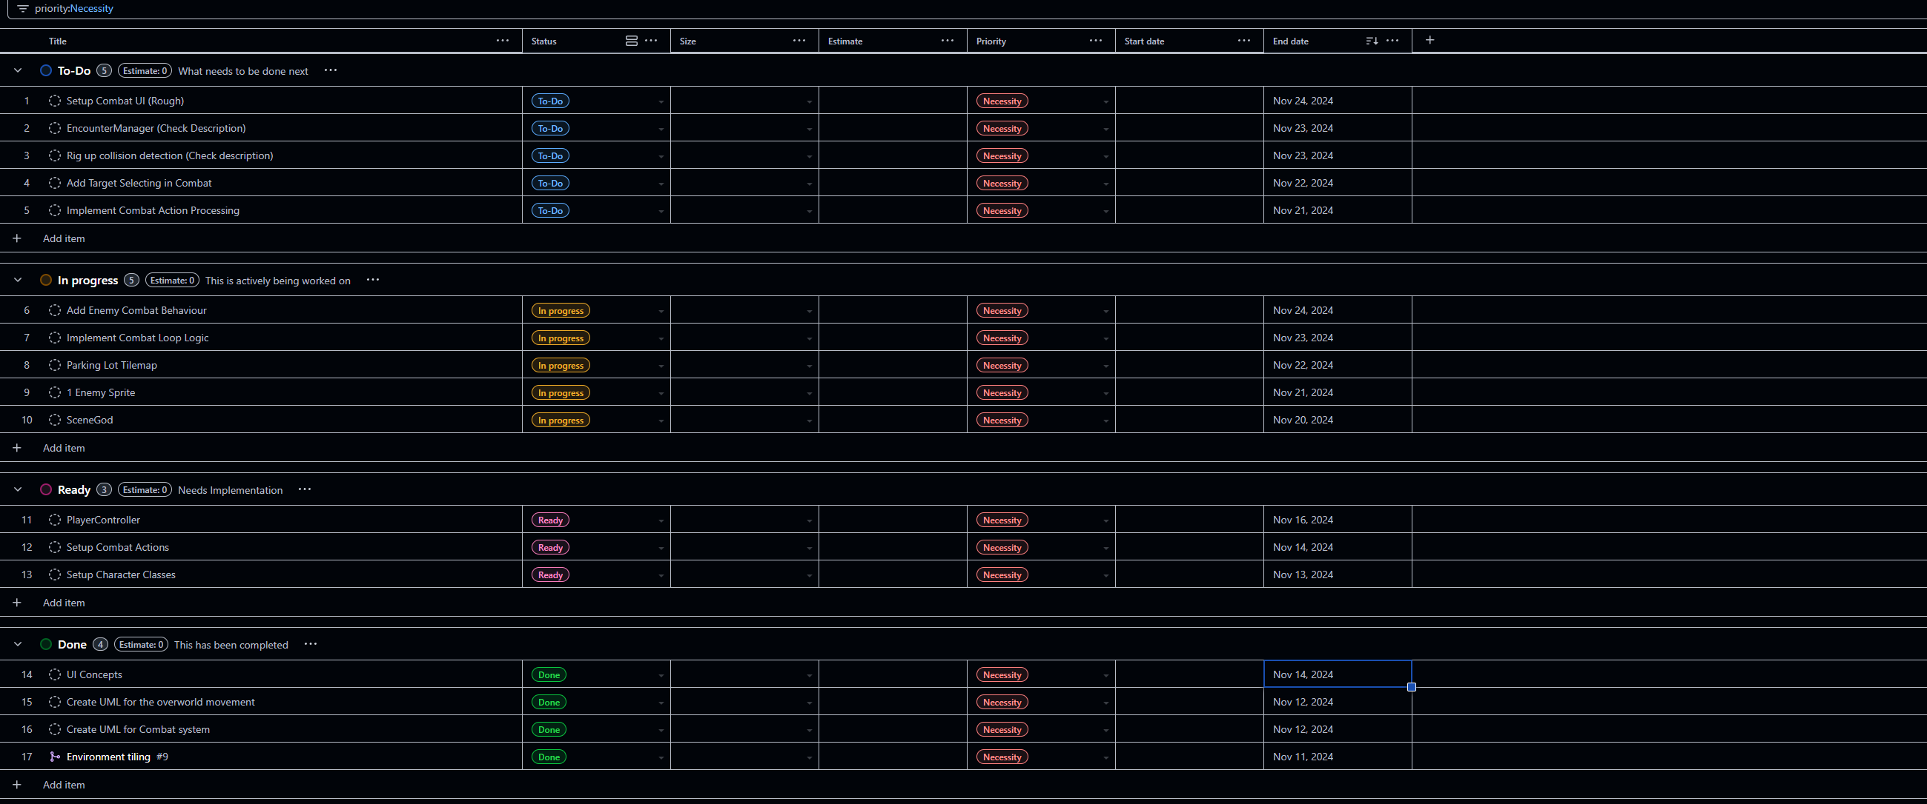

Roadmap:
The roadmap shows the dates in relation to the current date (which is the red line). Anything to the left should be complete, and to the right is still in progress. Interestingly enough, even though I did not expect to have made that accurate due dates for everyone they all worked well, and everyone got things done on time, and we also didn’t have anyone sitting around without tasks to do.
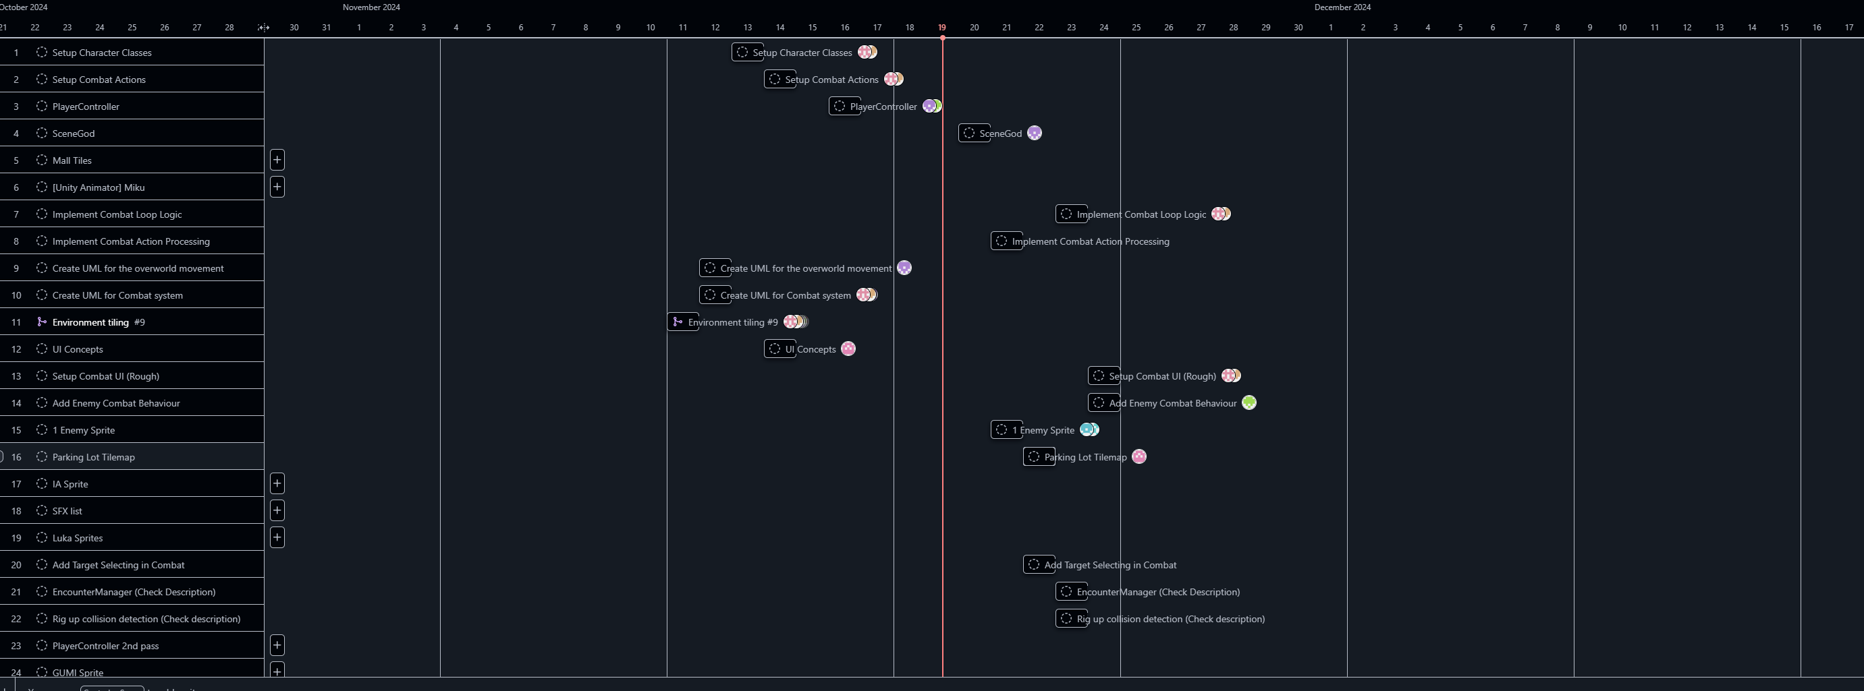

Roadmap Sorted by deadline:
The primary difference in this image below is that I had added the 2 green lines you see which are the hard deadlines I had set for when the MVP (minimum viable product) must be done, and when playtesting is. Notice I left 2 days after the MVP is done to allow for leeway in case things take longer, I would have liked to have more time between these dates, but we had committed to a playtest which can’t be rescheduled. In the end we had some work that was left to the last minute despite my best efforts to involve the person assigned to that task.
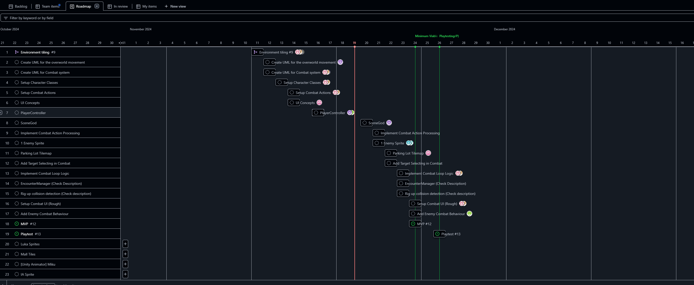

Post – initial playtest roadmap
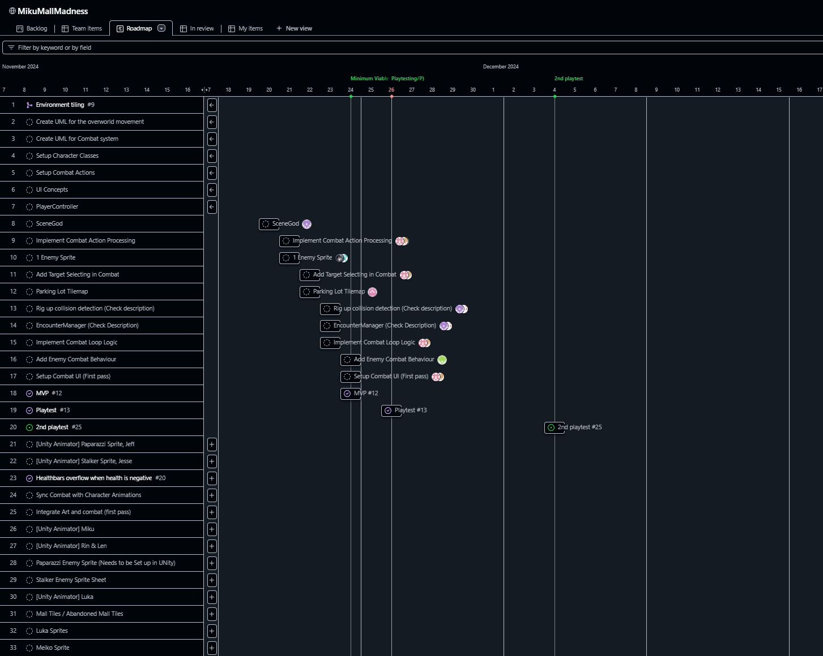

Final result:
I’d like to draw your attention here to the Done category, where we have 50 tasks completed, which is a massive amount of work, and I would also like to note that none of my work involving creating and managing this board, along with working with group members and coordinating is logged on here. Mainly since it felt weird to have a kanban board for the kanban board. I am extremely proud of our group and the progress we have made. I think that despite the immense challenges we all faced, we really did succeed. And I do also believe that if we had another week, we could have had a much more fleshed out final product. There were many times where I was working overtime to get things to integrate at the end.
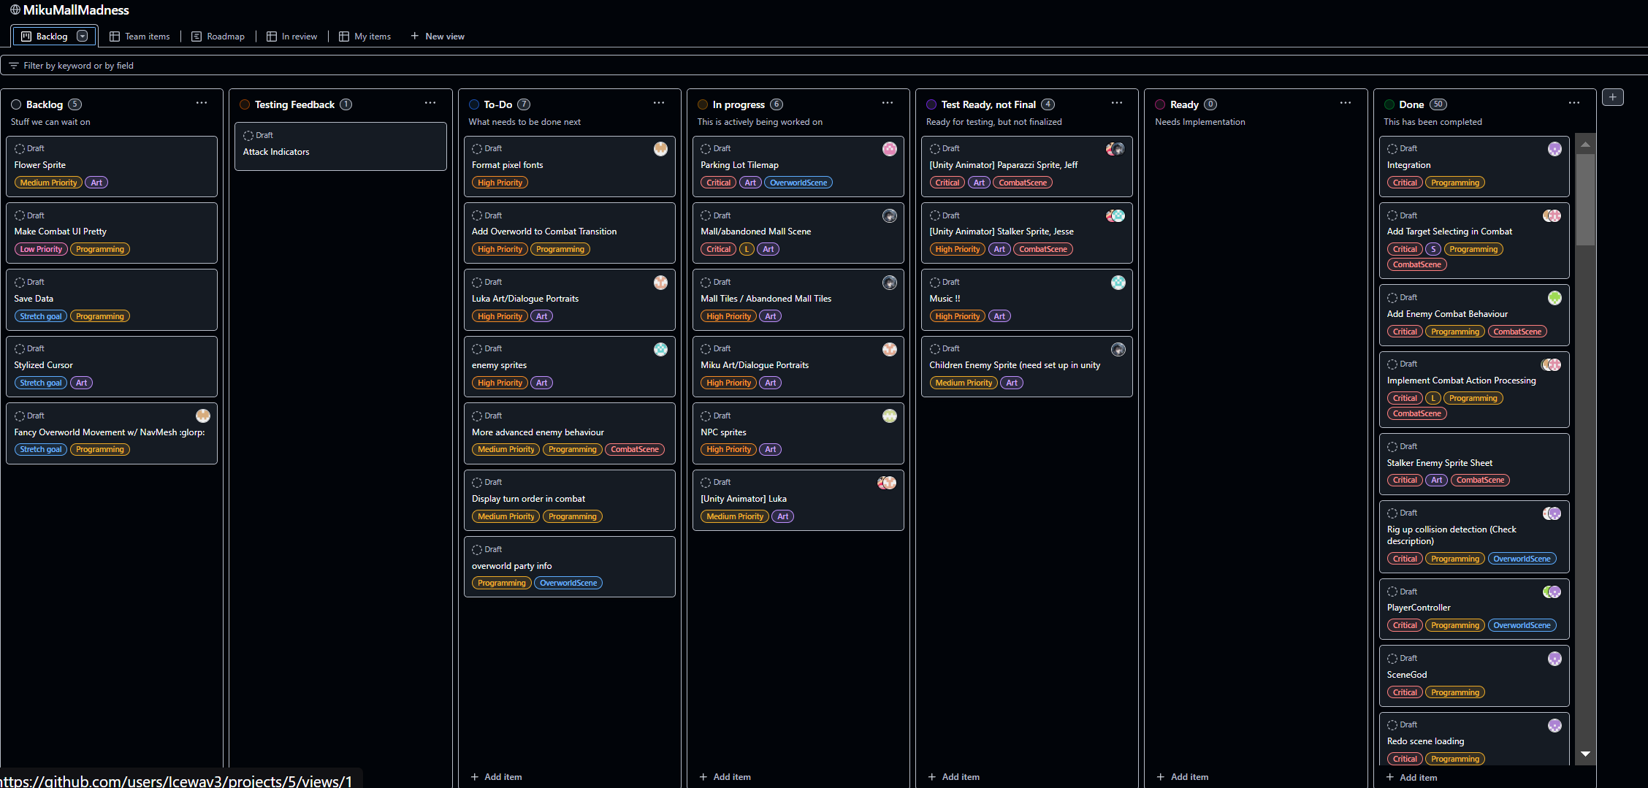

Final timeline & history
An interesting thing here I would like to note is the work slowdown when all the other final projects where due, after the first playtest we all had to redirect most of our efforts elsewhere to ensure other projects were completed. So while there was a substantial amount of changes between the playtests, it was no where near the production we had going prior to that.
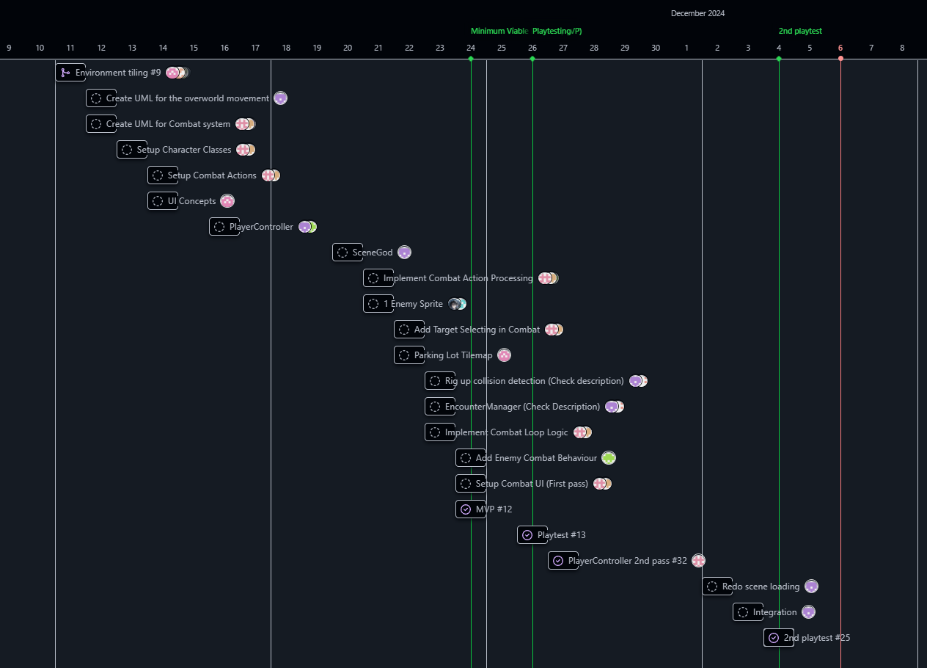

Project Management Reflection:
Overall, I would like to re-iterate; I think this was a huge success, especially considering how the odds were certainly stacked against us. We had many group members who had little to no experience working collaboratively and that presented big challenges for us, and especially me. It also led to some conflict resolution, that I had learned a lot from. I feel like that in future I will be able to notice the stem of problems regarding communication earlier on which can prevent them from becoming a conflict. I did also face significant challenges trying to involve some group members, as best as I tried, they would not work independently.

My job as a project manager is to be there to support and assist people in completing tasks if they are unsure or feeling overwhelmed but I am not supposed to be doing the work for people. Especially in this Along with that I need to operate on the mutual understanding that everyone is independent. If questions come up, they will ask me, and if they finish their task, they can take another from our long TODO list on the project board. It is impossible for me to micromanage that with 11 people, and I also have to be doing programming alongside the project management. If I do try to assist too much, it prevents them from having the opportunity to learn to be independent. The flipside is if I don’t babysit them nothing gets done, and then the work falls to me to complete. This is a challenge I had with spike, and many times I have reached out and asked if there is anything I can to do help clarity, and we have spent countless hours in voice calls with me guiding him. I think this was potentially my point of failure. After seeing spike being unable to get things done for our first deadline despite my best efforts to support him, I ended up spending the majority of my time later in the project trying to help. The reason I feel like this was my mistake is that I noticed once I started pair programming with him in a voice call, and asking questions to deeper understanding, he stopped working outside of those voice calls entirely. Which then leads to the same result of taking up too much of my time.

Another issue that came up I’ll cover briefly was that Cate and Alex did take over the combat system a little too much and while I had assigned them to just create a diagram to then convey how things should be setup so programmers with less experience like myself could easily design them given the requirements outlined. They did this but also without telling me had finished most of the combat system without telling anyone since they didn’t want it to be done incorrectly. I did talk to them about this as it was a bit of a problem since often ideas would get shut down quickly during discussions since they had not shared much info of the backend. After we talked about this though Cate was extremely receptive and made huge efforts to be more open and I saw an amazing improvement from her. Alex is on the right track as well I can clearly tell. But I think she needs a bit more time, since she has not had as much experience working in group settings, which is completely valid. Overall this is something I think I could have prevented better in future, as the signs were there early on when my ideas were getting shutdown, but I ignored it until I had Vince reach out to me saying he felt his ideas were not getting heard by them. That’s when I acted, I didn’t want to earlier in the case that maybe the ideas I had come up with were just bad. But when it’s someone else’s it bothers me, which is a issue I am working on improving myself.

Overall, I can’t stress how much I feel the project was a huge success, we had an extremely talented team, which I am so proud of. Especially since everyone has learned so much during the project.s I had given responsibility of art leads and programming leads to Frank and Marlena, and I then mentioned I want a few others in each team to support those leads, being Vince and Caithlyne for the art team, and Cate and Alex, for the programming team. Vince who is usually fairly reserved really started to shine when I started doing my thing and making everyone comfortable with speaking up, which I was really happy to see, and did a great job support frank. Caithlyne also really started to engage a lot which was great to see. The others in the art team were very in contact with each other but less so in a group sense, which is ok, as Frank did an excellent job communicating their overall thoughts well as to me. Marlena, I think struggled a bit with the leadership role having not been in one before, but with some help and a bit of a push from me to get her to engage with Cate and Alex, she actually really fell into place and helped out with the Combat system and designing the enemy AI. Which I loved to see since I could tell she was feeling a bit excluded initially, so I had involved her with some of my tasks then later, Cate and Alex really started working with her. Cate and Alex who are both very talented programmers did an amazing job with the combat system. Tiffany and Jayrald made some of the most beautiful levels I’ve seen for the game, Spike got everything done even while juggling working a job for almost every day outside of school hours which is a impressive feat. Caithlyne & Apple did amazing work on character designs making them feel so full of life, and Vince did amazing work animating them and giving them character as well as making our combat scenes so damn cool.

My code contribution:
I worked on the scene god class, which is a singleton, and since many people in my group were unfamiliar with singletons I made sure to make it very accessible and easy to use. This snippet is just the singleton pattern with extensive documentation for other programmers.
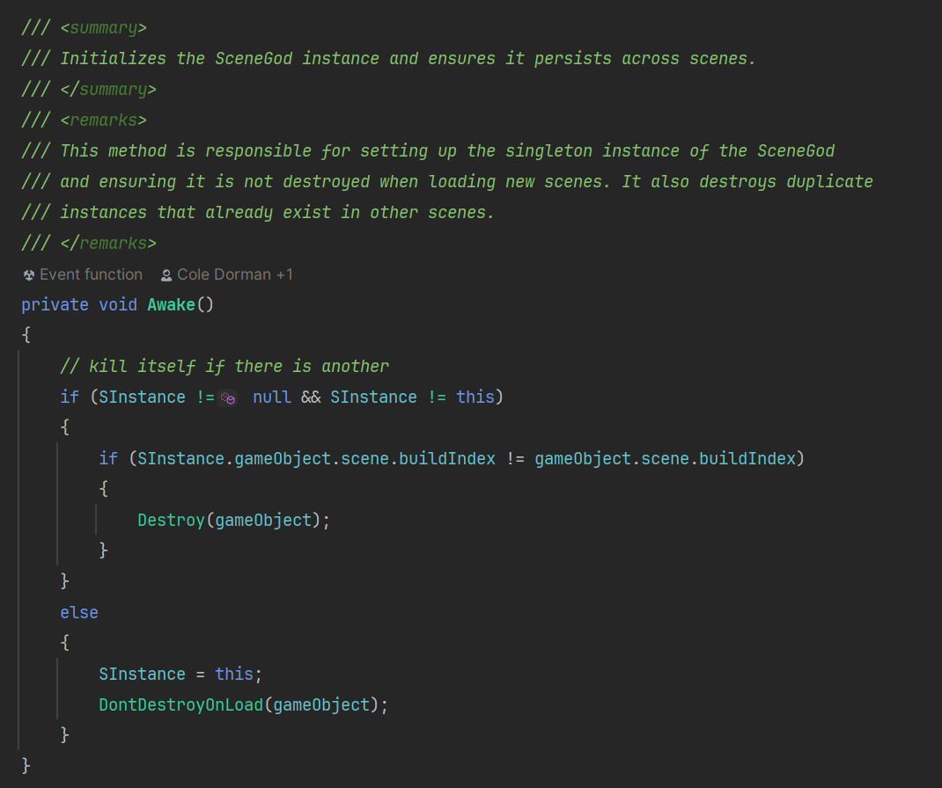
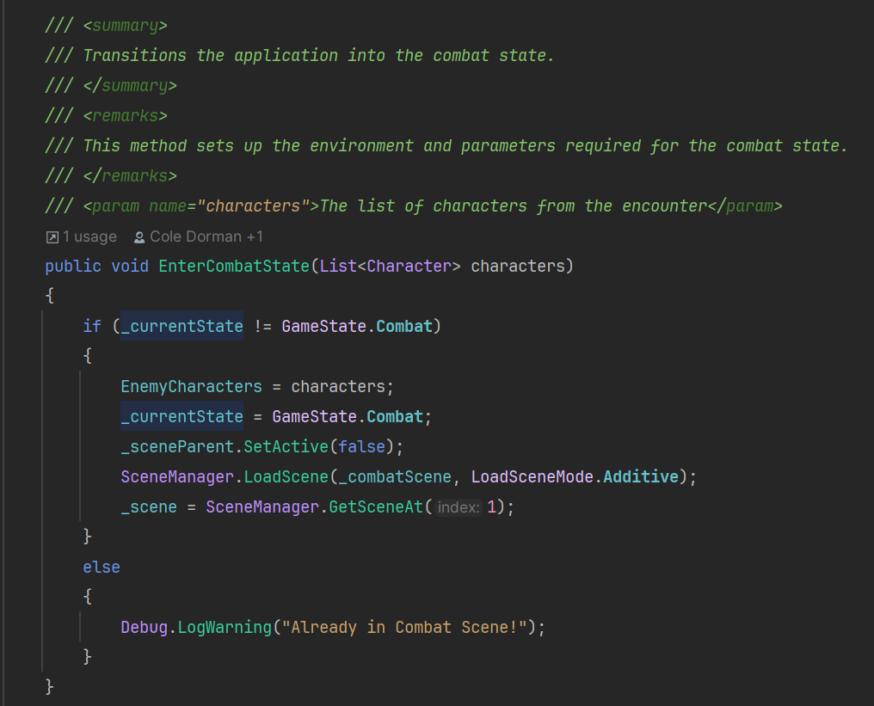
This next function is called by other classes so once again has extensive documentation; it is used in conjunction with the following value, which is the list of characters. Singletons should never reference other classes, and all information should be passed to it to prevent null references when scenes change.
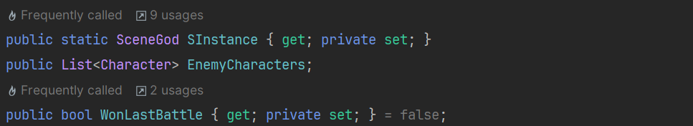
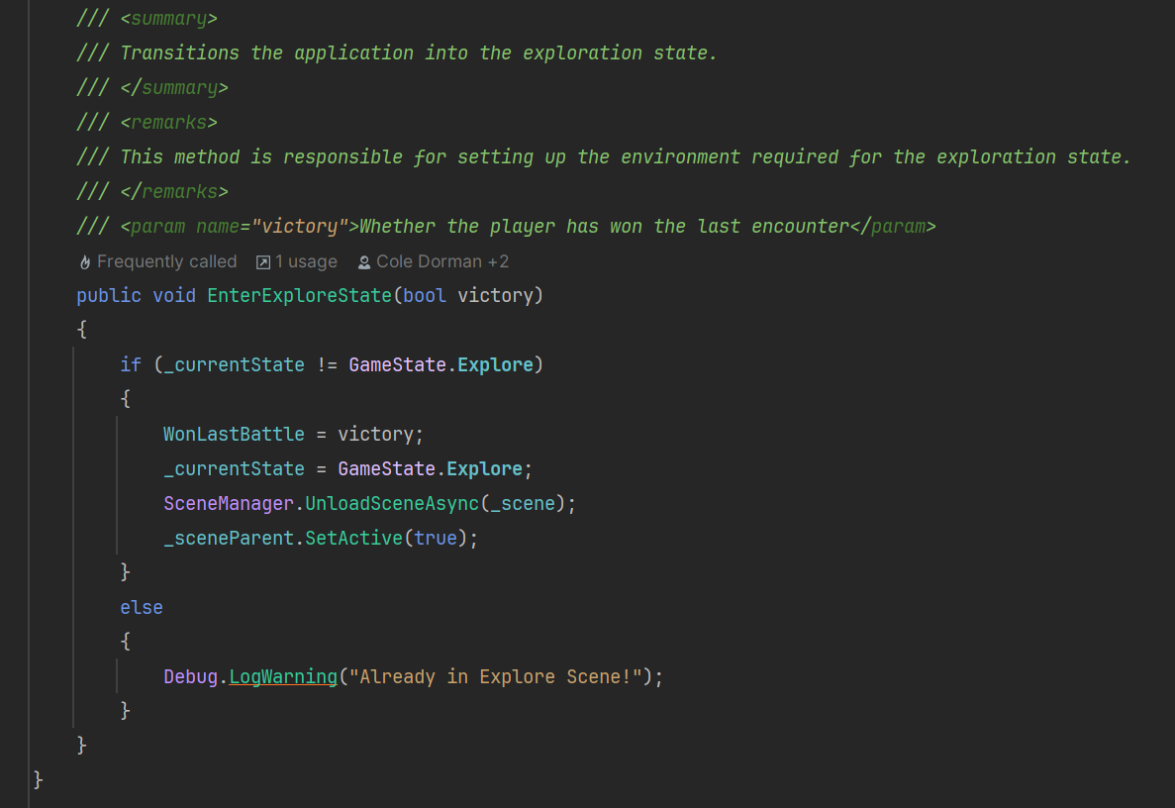
Lastly this method is also called by other people’s classes so it’s well documented and designed to be implemented without having to know about the code. The method name is very obvious to infer what it does, and it’s clearly documented. It is also used in conjunction with WonLastBattle so that others can pass the result of the battle scene into it to then transfer between scenes where data is lost otherwise, and other scripts can then access it.

Overall, I had to design this much earlier on than the scripts that would implement this, which forced me to design it to be easily utilized, and easy to expand but closed to change existing code. Generally, it’s also important to keep singletons storing as little as possible as a over reliance on them is very bad practice.
Links:
GitHub
Project board

